**Workshop frontend day 2**

**AngularJS Introduction**

1. Create new project in WebStorm(‘angularhr’);

2. Copy from GitHub project from the folder ‘day2-files’ the following files: ‘bower.json’, ‘Gruntfile.js’ and ‘package.json’;

3. Run from CMD(inside the project folder) the following commands:

* npm install
* bower install

4. Create file ‘index.html’;

5. Create folder ‘scripts’;

6. Index.html should look like this:

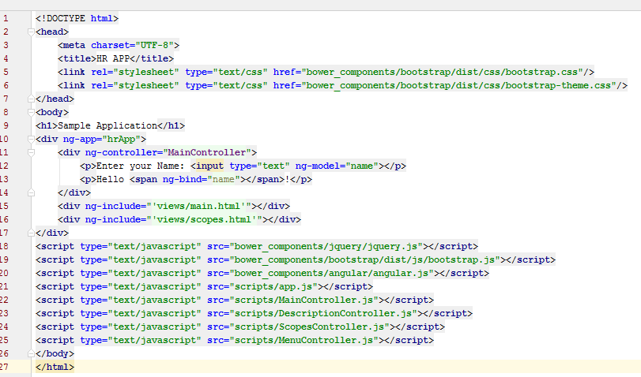

7.Create in scripts folder the app.js file where you should define the hrApp angular module.

8.Create in the scripts folder the MainController.js file where you should define the angular controller MainController. MainController should do:

1. Inject $scope and $rootScope.
2. Print the name value from the scope of the MainController.

9. grunt connect:server in the cmd console.

10. Create scripts/DescriptionController.js and populate an angular controller with the same name with the following code:

$scope.title = 'Two Way Binding Demo';

$scope.childtemplate = 'templates/childscope.html';

$scope.resetFirstVariable = function() {

$scope.firstVariable = undefined;

};

$scope.setFirstVariable = function(val) {

$scope.firstVariable = val;

};

11. Add to the index.html a <div></div> which includes a html template controlled by DescriptionController.

12. Complete the html template:

<div class="container">

<div class="jumbotron" ng-show="descriptionShow">

<h1>{{title}}</h1>

<p class="lead">

A simple demo application.

</p>

<p class="lead">

In this application we will use AngularJS framework.

</p>

</div>

<p>

<a class="btn btn-primary btn-lg" role="button" ng-click="toggleDescriptionShow()">Show/Hide Description</a>

</p>

</div>

13. Use the directive ‘ng-hide’ to show/hide the description;

14. Create ScopesController in the scripts folder with the following content:

$scope.title = 'Two Way Binding Demo';

$scope.childtemplate = 'templates/childscope.html';

$scope.resetFirstVariable = function() {

$scope.firstVariable = undefined;

};

$scope.setFirstVariable = function(val) {

$scope.firstVariable = val;

};

15. Create ‘scopes.html’ in the views folder:

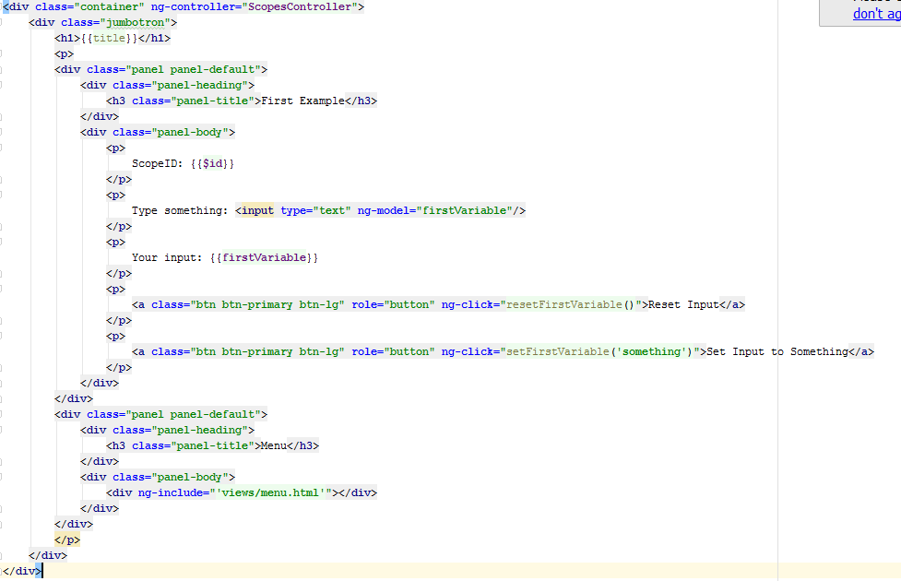

16. Use ng-include to include the scopes.html in index.html.

17. Add in ‘menu.html’ a new element in the links list, below the Home link the following element:

<li class="dropdown" ng-controller=”MenuController”>

<a href="" class="dropdown-toggle" data-toggle="dropdown">Demo actions<span class="caret"></span></a>

<ul class="dropdown-menu" role="menu">

<li ng-repeat="action in demoActionList"><a href="{{action.url}}">{{action.label}}</a></li>

</ul>

</li>

18. Create MenuController:

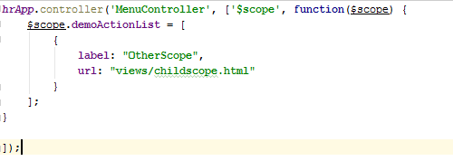

19. Add ‘childscope.hmtl’ view:

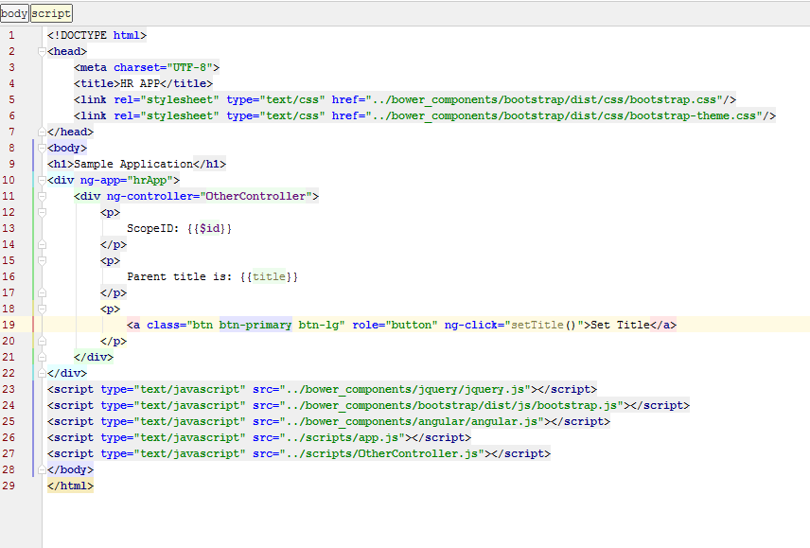20. Add OtherController where you should implement the setTitle function.

21. Create a new route in your application ‘/demomath.html’.

22. Show the link for this route in the ‘Demo actions’ dropdown from the menu;

23. In this page create two inputs(‘Number A’ and ‘Number B’). Below this inputs show the 4 math operations(addition, subtraction, multiplication, division);

24. Create a new empty project. This should be start of your final application. Create the index.html and the needed controllers in order to obtain a menu like this.

You should use ng-include to include a menu.html template, and a ng-repeat to iterate through the Employees options. The options from the Employees menu should be “List Employees”…

For the menu use the navbar class from bootstrap: <http://getbootstrap.com/components/#navbar>

